# **Name: Abdurrahman Qureshi**

# **Roll No: 210451**

Practical No: 7&8

**1) WAP in java to convert a byte into short, char, int, long, float, double**

**CODE:**

import java.util.*;

class EXP7Byte{

public static void main(String args[]){

byte n;

Scanner sc = new Scanner(System.in);

System.out.print("Enter a number form 0 to 127 : ");

n = sc.nextByte();

System.out.println();

char c = (char) n;

int i = n;

float f = n;

short s = n;

long l = n;

System.out.println("In character format : " + c);

System.out.println("In integer format : " + i);

System.out.println("In float format : " + f);

System.out.println("In short format : " + s);

System.out.println("In long format : " + l);

}}

**OUTPUT:**

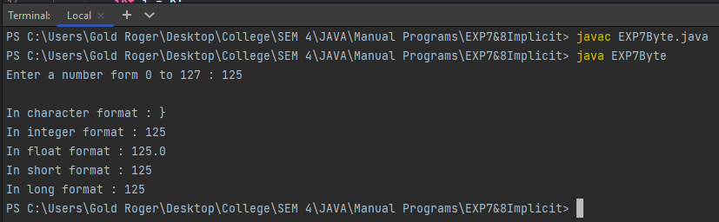

**2) WAP in java to convert a char into float, double , int , long**

**CODE:**

import java.util.*;

class EXP7Char{

public static void main(String args[]){

Scanner sc = new Scanner(System.in);

System.out.print("Enter a number : ");

char c = sc.next().charAt(0);

System.out.println();

int i = c;

float f = c;

double s = c;

long l = c;

System.out.println("In character format : " + c);

System.out.println("In integer format : " + i);

System.out.println("In float format : " + f);

System.out.println("In short format : " + s);

System.out.println("In long format : " + l);

}}

**OUTPUT:**

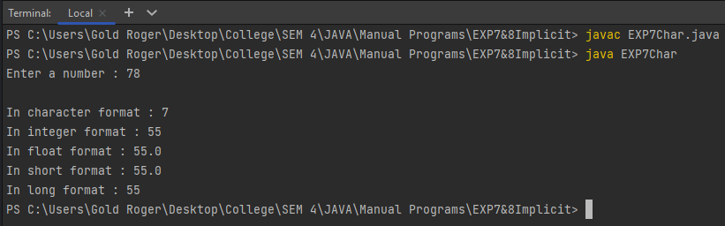

**3) WAP in java to convert kilometres(int) to meters(double) and miles(double)**

**CODE:**

import java.util.*;

class EXP7Kilo{

public static void main(String args[]){

Scanner sc = new Scanner(System.in);

System.out.print("Enter a number to convert to miles and meters : ");

int km = sc.nextInt();

System.out.println();

double miles = (km / 1.6);

double meters = km * 1000;

System.out.println("In KM : " + km);

System.out.println("In M : " + meters);

System.out.println("In MI : " + miles);

}

}

**OUTPUT:**

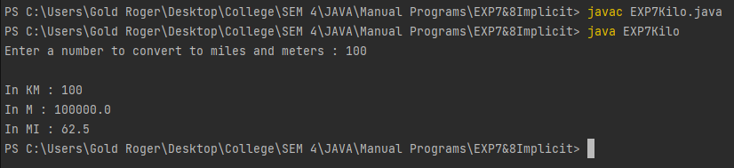

**4) WAP in java to find roots of a quadratic equations – roots(double) - a,b,c – (int)**

**CODE:**

import java.util.*;

class EXP7QE{

public static void main(String args[]){

int delta;

double r1 = 0, r2 = 0;

int a , b , c;

double r1v , r2v;

Scanner sc = new Scanner(System.in);

System.out.print("Enter value for first coefficient :");

a = sc.nextInt();

System.out.println();

System.out.print("Enter value for second coefficient :");

b = sc.nextInt();

System.out.println();

System.out.print("Enter value for third coeffiecent :");

c = sc.nextInt();

System.out.println();

delta = ((b*b) - 4 * a * c );

r1v = (-b + Math.sqrt(delta)) / (2 * a);

r2v = (-b - Math.sqrt(delta)) / (2 * a);

if(delta < 0){

System.out.println("The roots are not real and imaginary...");

r1 = r1v;

r2 = r2v;

} else if (delta > 0) {

System.out.println("The roots are real and unequal...");

r1 = r1v;

r2 = r2v;

} else if (delta == 0) {

System.out.println("The roots are real and equal...");

r1 = r1v;

r2 = r2v; }

System.out.println();

System.out.println("Root 1 = " + r1);

System.out.println("Root 2 = " + r2); }}

**OUTPUT:**

